WHAT IS A DENTAL IMPLANT?

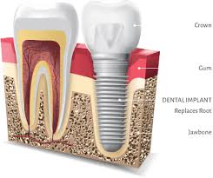

* Implant is the best and most innovative way to replace the missing tooth.
* Implant is basically the artificial root of the tooth, which is place in the bone with the help of a very minor surgery.
* It is made up of titanium which is most bio compatible metal discovered on earth as of now.
* Implant can be placed for replacing a single tooth or even for rehabilitation of entire mouth for the patients who don’t have even a single tooth in their mouth.
* Implant can be placed immediately after extraction (except some cases with a huge infection) or we can plan them later after extraction (like in bone infection cases where we have to clean the bone leave it for healing for quite some time let’s say around 6-8 weeks).

DENTAL IMPLANT OPTIONS

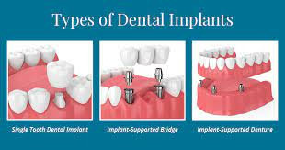

SINGLE TOOTH DENTAL IMPLANT-

Best to replace a single missing tooth without intentionally damaging the existing healthy teeth.

MULTIPLE DENTAL IMPLANTS-

Whenever there is absence of 3 teeth we place 2 implants and then a bridge over it as shown in the picture above.

FULL MOUTH IMPLANTS-

Usually 4-8 implants are placed in a single jaw and later on a complete denture (semi fixed or fixed) is given on them as prosthesis.

This is a treatment option when the patient wants fixed replacement of the teeth.

PROCEDURE OF PLACING AN IMPLANT

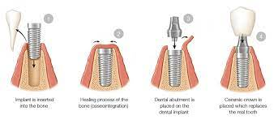

It is usually done 2 phases-

* Implant placement
* Prosthesis (crown/bridge/denture) placement.

Procedure-

1. Placing the implant in the missing space
2. Leaving the implant in the bone for 10-12 weeks for osseointegration. osseointegration is the process when our bone integrates or fuses itself with the implant placed. This the most important step because it decides the level of stability of implant placed.
3. Assessing the implant and bone health and the osseointegration status in periodic visits.
4. After achieving the perfect osseointegration we load the implant or we put the prosthesis.

TYPES OF IMPLANT PROSTHESIS-

SINGLE IMPLANT CROWNS.

IMPLANT BRIDGES (2-3 UNITS)

IMPLANT SUPPORTED DENTURES

* SEMI FIXED IMPLANT DENTURE(can be removed by patient)
* FIXED IMLANT DENTURE (can be removed by implantologist only).

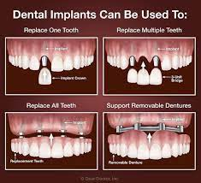

FAQs

1.How painful is the implant procedure?

It is not at all painful because the procedure of minor implant surgery is done under local anesthesia.

2.What is the durability of implant treatment?

It is a kind of long lasting or permanent solution for missing teeth but maintaining hygiene especially in the implant region is quite mandatory to increase the durability of the implant.

3.How does the implant stabilize itself in the bone?

Implant is made up of titanium metal which is biocompatible metal and this feature makes implant eligible enough to be placed in the bone. and this makes feature makes the fusion of bone with implant easy.so implant is stabilized in the bone because the bone integrates itself with the implant.

4.Why does the complete implant treatment take so long?

It takes roughly around 3 months (might vary from case to case).it takes long because the bone needs that much time to integrate itself with the implant. This is the most crucial step and has to be perfect.

5.Is the implant surgery safe for all?

Yes, implant surgery is a very minor procedure and is completely safe for everyone but we have to take little precautions and plan the procedure in a certain way in the patients with medical conditions like diabetes, blood pressure, and cardiac problems.